Total Lunar Eclipse 9 Jan 2001

Observation Report

Site Taipo, Hong Kong

Time 9-10 Jan 2001 overnight

Seeing Air steadiness 4~5/10 in midnight, 6~7/10 from 1 to 4 am. Later a cold front and
heavy clouds approached from the NW sky. All observations ceased after 5:30 am.

Almanac Information

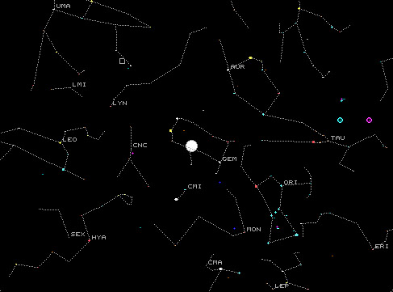
Moon
N
W
10 Jan 2001
1:30am HK
Saturn
Jupiter
E
S

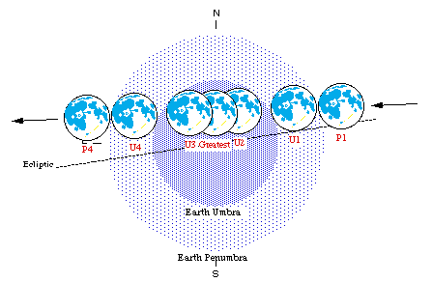
E AST
0 20 40 60 80
Arc Minutes
U3 Max U2
U1
U4
P1
P4
WEST
Total Lunar Eclipse |  | HKT  10 Jan 2001 | UT  9 Jan 2001 | Moon’s  Altitude
P1 | 入半影 | 1: 43.3 am | 17:43 | 71⁰
U1 | 初虧 | 2:41.9 am | 18:42 | 58⁰
U2 | 食既 | 3:49.6 am | 19:50 | 43⁰
Max | 食甚 | 4:20.6 am | 20:21 | 36⁰
U3 | 生光 | 4:51.6 am | 20:52 | 29⁰
U4 | 復圓 | 5:59.2 am | 21:59 | 15⁰
P4 | 食終 | 6:57.7 am | 22:58 | 3⁰

- Angular diameter of the moon = 33.4’

- Delta Gemini (δ GEM, magnitude 3.5)
is close to the moon during total eclipse.

Equipment FS102 (10cm f/8 refractor) on motorized mount + Ortho 25mm eyepiece +
Casio QV2300 CCD camera for afocal imaging. Binocular for visual.

Raw Images from CCD Camera

Details in Table 1. The shaded raw images are processed with Photoshop and grouped as LE_color.jpg M010109a.jpg M010109b.jpg M010109c.jpg M010109d.jpg W010110t.jpg in the Appendix.

Table 1

Raw Image  No. | Camera Exposure Data # |  |  |  | Calculations * |  |  |  | Remarks
Raw Image  No. | HKT  10 Jan 2001 | UT  9 Jan 2001 | F-stop Shutter |  | Relative  Brightness of the Moon | Moon Disk Diameter  (pixels) | Separation of δ Gem  from moon’s limb |  | Remarks
 |  |  |  |  |  |  | In pixels | In arc min. | Remarks
0110 0002 | 1:34 am 17:34 |  | F5.6 1/666 s | AP | 5330
0110 0003 | 1:42 am 17:42 |  | F5.6 1/621 s | AP | 4970
0110 0004_1 | 1:55 am 17:55 |  | F5.6 1/621 s | AP | 4970
0110 0005_1 | 2:01 am 18:01 |  | F5.6 1/546 s | AP | 4370
0110 0006_1 | 2:15 am 18:15 |  | F5.6 1/523 s | AP | 4180
0110 0007_1 | 2:21 am 18:21 |  | F5.6 1/574 s | AP | 4590
0110 0008 | 2:23 am 18:23 |  | F5.6 1/495 s | AP | 3960
0110 0010 | 2:34 am 18:34 |  | F5.6 1/414 s | AP | 3310
0110 0011 | 2:35 am 18:35 |  | F5.6 1/332 s | AP | 2660
0110 0012_1 | 2:37 am 18:37 |  | F5.6 1/299 s | AP | 2390
0110 0013_1 | 2:44 am 18:44 |  | F5.6 1/196 s | AP | 1570
0110 0014_1 | 2:49 am 18:49 |  | F5.6 1/201 s | AP | 1610
0110 0015 | 3:01 am 19:01 |  | F5.6 1/102 s | AP | 820
0110 0016_1 | 3:09 am 19:09 |  | F5.6 1/45 s | AP | 360
0110 0018_1 | 3:20 am 19:20 |  | F5.6 1/8 s | AP |  | 816 | 119 | 4.9 | Inadequate exposure
0110 0019 | 3:21 am 19:21 |  | F5.6 1/8 s | AP |  | 819 | 116 | 4.7 | Inadequate exposure
0110 0020_1 | 3:22 am 19:22 |  | F5.6 1/8 s | AP |  | 656 | 82 | 4.2 | Inadequate exposure
0110 0021_1 | 3:23 am 19:23 |  | F5.6 1/8 s | AP |  | 652 | 79 | 4.0 | Inadequate exposure
0110 0022_1 | 3:26 am 19:26 |  | F2.8 1/40 s | SP |  | 816 | 78 | 3.2 | Inadequate exposure
0110 0023_1 | 3:27 am 19:27 |  | F2.8 1/40 s | SP |  | 819 | 74 | 3.0 | Inadequate exposure
0110 0024_1 | 3:30 am 19:30 |  | F5.6 1/20 s | SP |  | 820 | 51 | 2.1 | Inadequate exposure
0110 0025 | 3:34 am 19:34 |  | F2.8 1/32 s | AP |  | 815 | 42 | 1.7 | Inadequate exposure
0110 0026 | 3:35 am 19:35 |  | F2.8 1/32 s | AP |  | 817 | 40 | 1.6 | Inadequate exposure
0110 0027_1 | 3:39 am 19:39 |  | F2.8 1/32 s | AP |  | 818 | 26 | 1.1 | Inadequate exposure
0110 0028 | 3:43 am 19:43 |  | F2.8 1/8 s | AP |  | 817 | 21 | 0.86 | Inadequate exposure
0110 0029_1 | 3:44 am 19:44 |  | F2.8 1/4 s | SP |  | 817 | 20 | 0.82 | Inadequate exposure
0110 0030_1 | 3:45 am 19:45 |  | F2.8 1/2 s | SP | 8 | 816 | 20 | 0.82
0110 0031 | 3:46 am 19:46 |  | F2.8 1 s | SP | 4 | 933 | 23 | 0.82
0110 0004 | 3:51 am 19:51 |  | F2.8 1.6 s | SP | 2.5 | 821 | 24 | 1.0
0110 0005 | 3:54 am 19:54 |  | F2.8 2 s | SP | 2 | 821 | 26 | 1.1
0110 0006 | 3:56 am 19:56 |  | F2.8 2 s | SP | 2 | 823 | 32 | 1.3
0110 0007 | 4:00 am 20:00 |  | F2.8 2 s | SP | 2 | 790 | 48 | 2.0
0110 0012 | 4:13 am 20:13 |  | F2.8 3.2 s | SP | 1.3 | 939 | 146 | 5.2
0110 0013 | 4:14 am 20:14 |  | F2.8 3.2 s | SP | 1.3 | 835 | 145 | 5.8
0110 0014 | 4:18 am 20:18 |  | F2.8 4 s | SP | 1 | 832 | 169 | 6.8
0110 0016 | 4:21 am 20:21 |  | F2.8 4 s | SP | 1 | 771 | 190 | 8.2 | Eclipse maximum
0110 0018 | 4:28 am 20:28 |  | F2.8 4 s | SP | 1 | 767 | 248 | 10.8
0110 0020 | 4:30 am 20:30 |  | F2.8 4 s | SP | 1 | 775 | 285 | 12.3
0110 0021 | 4:39 am 20:39 |  | F2.8 4 s | SP | 1 | 638 | 303 | 15.9
0110 0022 | 4:40 am 20:40 |  | F2.8 2.5 s | SP
0110 0023 | 4:50 am 20:50 |  | F2.8 60 s | SP |  |  |  |  | Sky weather record
0110 0024 | 4:53 am 20:53 |  | F2.8 20 s | SP |  |  |  |  | Sky weather record
0110 0027 | 5:01 am 21:01 |  | F2.8 1 s | SP
0110 0029 | 5:03 am 21:03 |  | F2.8 0.8 s | SP
0110 0030 | 5:05 am 21:05 |  | F2.8 1/2 s | SP |  |  |  |  | Inadequate exposure
0110 0032 | 5:07 am 21:07 |  | F2.8 1/2 s | SP |  |  |  |  | Inadequate exposure
0110 0033 | 5:08 am 21:08 |  | F2.8 1/3 s | SP |  |  |  |  | Inadequate exposure
0110 0036 | 5:14 am 21:14 |  | F2.8 1/10 s | SP |  |  |  |  | Inadequate exposure
0110 0039 | 5:17 am 21:17 |  | F2.8 1/15 s | SP |  |  |  |  | Inadequate exposure
0110 0040 | 5:24 am 21:24 |  | F2.8 1/8 s | AP |  |  |  |  | Very cloudy

# Camera set at ISO80 1600x1200 pixels, spot metering; AP = Aperture Priority; SP = Shutter Priority * See Page 3 & 4 for explanations.

Color and Brightness of the Eclipsed Moon

In binocular, the moon was dull orange-red during eclipse maximum, not bright orange-red.
See the picture LE_color.jpg in the Appendix.

By eyes, the eclipsed moon was classified Level 2 in Danjon scale.

The brightness of the moon is estimated from the camera exposure data in Table 1. For instance, a correctly exposed image at F5.6, 1/60s means 4 times brighter than F2.8, 1/30s. The exposure F2.8, 4 sec is arbitrarily defined to yield Brightness = 1. On this scale, the full moon (Raw Image 0110 0002 to 0110 0003) is about 5000 times brighter than the eclipse maximum (Raw Image 0110 0016).

The curve below shows the change of moon’s brightness up to eclipse maximum. The change

is not much between P1 and U1 (i.e. when the moon was inside the Earth penumbra).

10000

3000

1000

300

100

30

10

3

1

0.3

17:30 18:00 18:30 19:00 19:30 20:00 20:30

9 Jan 2001 (Universal Time)
Relative Brightness
of the Moon
P1 入半影
U1 初虧
U2 食既
Max 食甚
2000
5000
equivalent to change
of one stellar magnitude

Angular Separation of δ GEM from the Moon

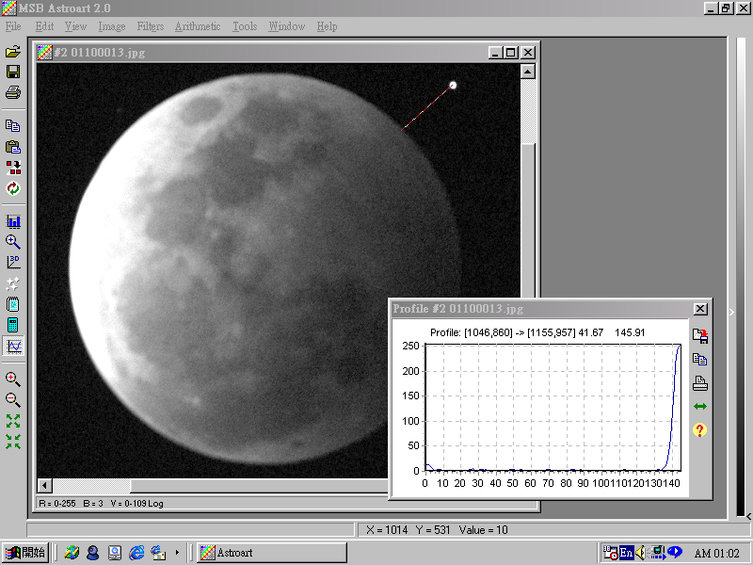
B
A
Angular separation of δ Gem
from the moon’s limb

= (B / A) x angular dia. of the moon
= 145 pixels / 835 pixels x 33.4 arc min.
= 5.8 arc min.
δ Gem
Profile Function
of AstroArt 2.0
Raw Image No.
0110 0013
Delta Gemini (δ GEM) was nearly occulted
by the moon’s southern limb in the course
of eclipse. Their angular separation was
calculated from the raw image data in
Table 1 with software AstroArt 2.0. See
the right figure and the graph below.

The nearest separation is ~ 0.8 arc minute,
seen in Taipo at 3:46 am HKT
(UT 19:46 of 9 Jan 2001).

19:20 19:30 19:40 19:50 20:00 20:10 20:20 20:30
9 Jan 2001 (Universal Time)
Separation in arc minutes

11.0

10.0

9.0

8.0

7.0

6.0

5.0

4.0

3.0

2.0

1.0

0

Angular separation of Delta Gemini (δ Gem)
from the southern limb of the Moon
Angular diameter of the Moon = 33.4 arc minutes
Observing site: Taipo, Hong Kong at 22⁰ 28.3’ N
114⁰ 13.2’ E, near sea level.

Movement of the Moon in the Sky

Raw Image No. 0110 0031 (UT 19:46) and 0110 0021 (UT 20:39) depart by ΔT (time interval)
= 53 minutes. During this interval, the moon moved eastward relative to δ GEM. The movement is measured 28.0 arc minutes with AstroArt 2.0. See the figure below.

Thus the daily movement of the moon is 28.0’ / ΔT x (1440 / 60) = 12.7 ⁰.

Compared to reference value (13.18 ⁰ per day in average), the above calculation is not precise. One error is due to ΔT not well resolved by the Casio camera. Another error is the uncertainty

to ascertain the position C in the figure below.

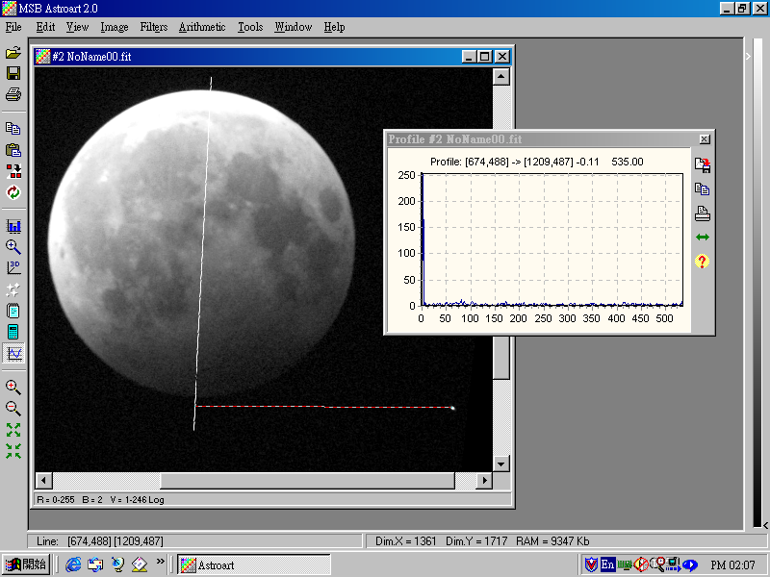
535 pixels (28.0 arc min.)

Reading of CD
= 535 pixels
638 pixels (33.4 arc min.)
Position of δ GEM in
this Image 0110 0021
Position of δ GEM in
Raw Image 0110 0031
C
D
Profile Function
of AstroArt 2.0

Conclusion & Discussion

This is the first Total Lunar Eclipse observed with satisfaction since 1990. The camera used, however, exhibits some limitations:

- Its internal clock resolves to minutes only, no seconds; it is not a precise timing tool.

- In Aperture Priority mode, the longest shutter speed is 1/8 sec. Some of the raw images are under-exposed because of this unawareness.

- The LCD screen is noisy and unable to display the dim moon at total eclipse. The telescope’s finder was used to guess the moon’s position in the LCD display.

Choose another camera next time.
Reported By: Alan Chu
18 Jan 2001

